**Preparation and Maintenance of ZOHO Books for EduConnect Learning Center**

**Project Team members: ANUSUYA.M, ASLINABEGAM.A, AUSTINA.A, BABITHA.S**

**1. INTRODUCTION**

**1.1 Overview:**

This project is deal with EduConnect Learning Center, an educational institution, uses Zoho Books to manage their donations, track expenses, and handle grant finances. They can generate donor receipts, track expenses related to educational programs, and generate financial reports. Zoho Books helps them maintain financial transparency and accountability.

**1.2 Purpose:**

By maintenance of accounts in ZOHO Books, We have created the Items, Vendors creation, Preparation of Purchase Order, Purchase Invoice, Customer creation, Preparation of Sales order, Sales Invoice, creation of bank account, creation of new accounts, recording journal entries, recording expenses, recording bank receipts and payments and viewing of financial reports like Profit & Loss account, Balance sheet, GST Reports, Journal report, Account receivable summary report, Account payable summary report, etc.,

**2. Problem Definition & Design Thinking**

2.1 Empathy Map

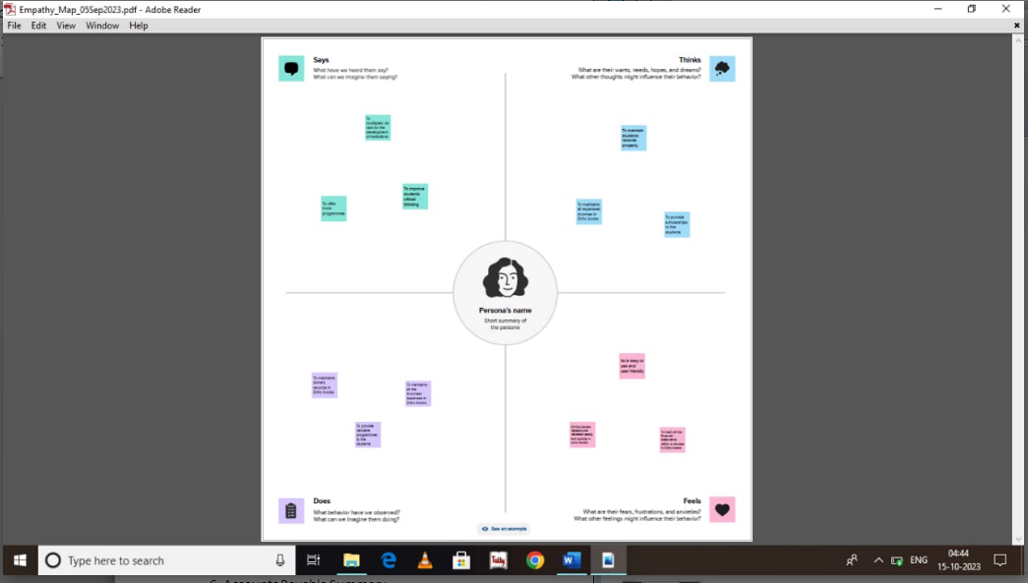

2.2 Ideation & Brainstorming Map

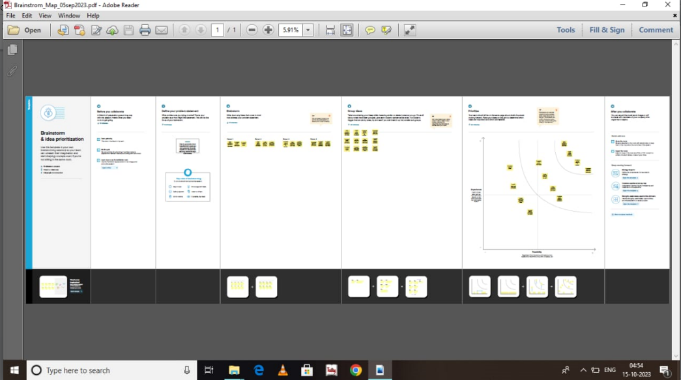

**3. RESULT:**

To Generate the Financial Reports:

1. Profit and Loss Account:

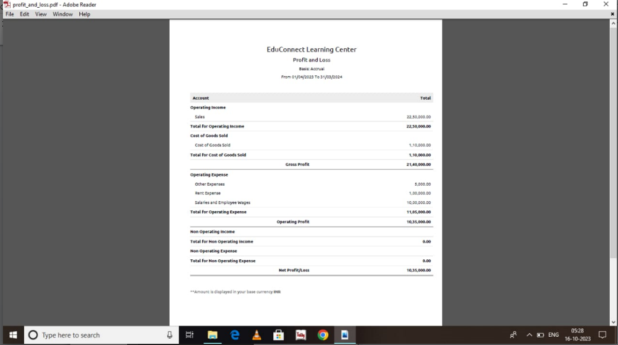

2. Balance Sheet

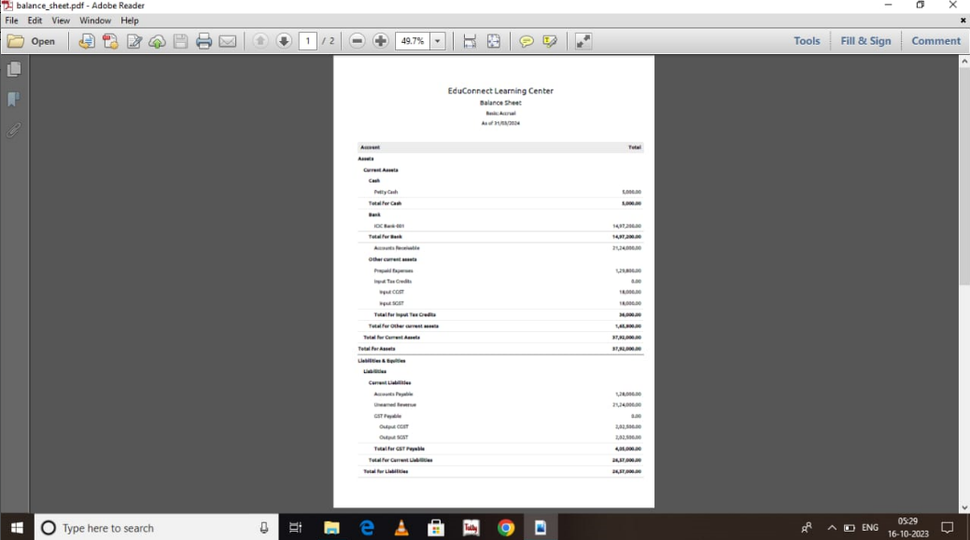

3. GST Reports

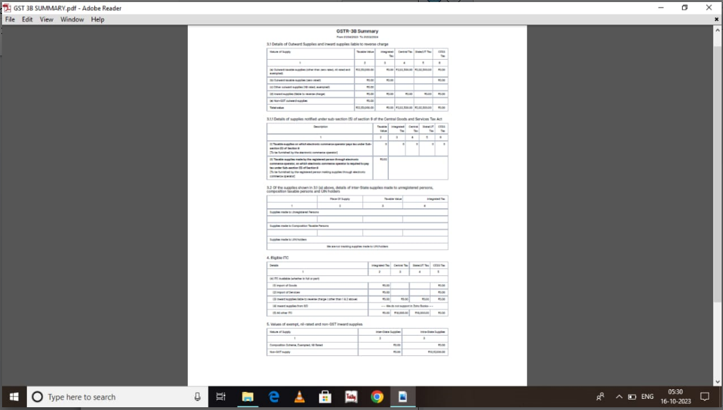

4. Journal Report

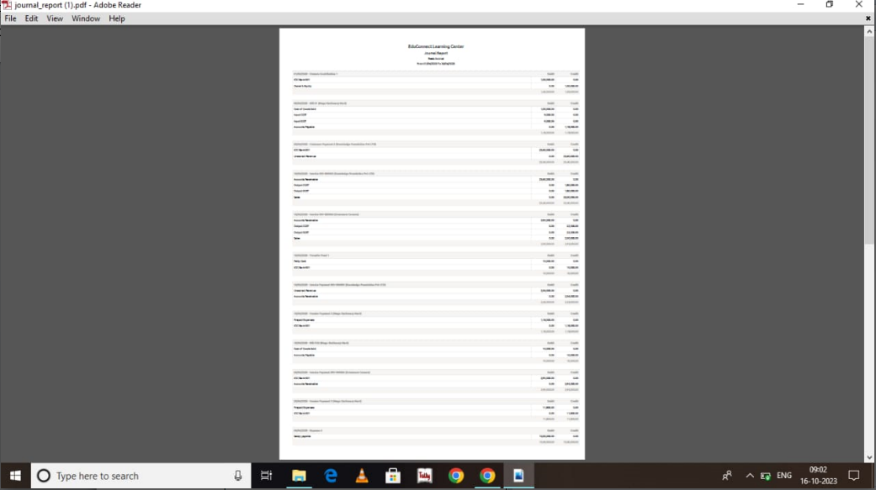

5. Accounts Receivable Summary

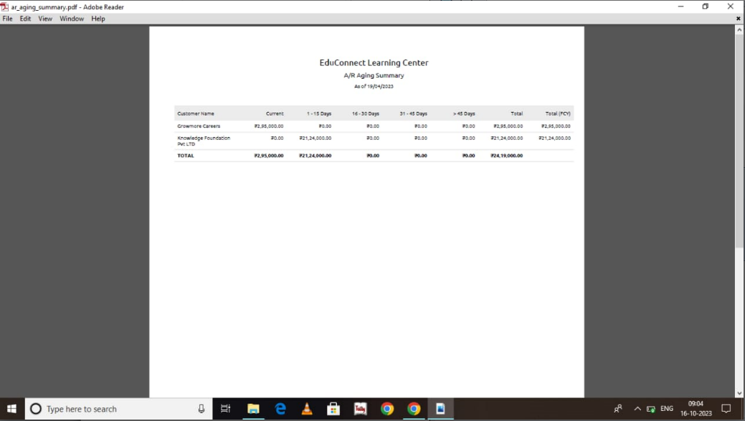

6. Accounts Payable Summary

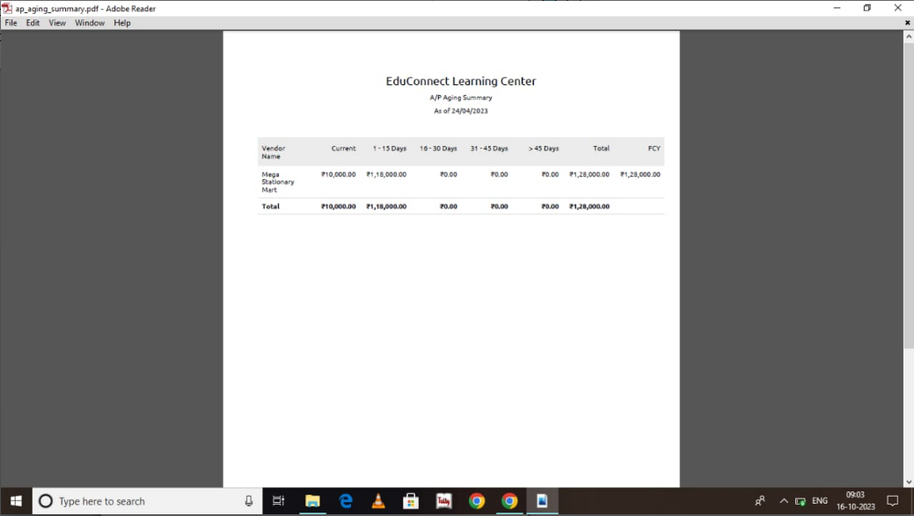

**4. ADVANTAGES & DISADVANTAGES**

List of advantages:

* ZOHO books is cloud based software, so we access the software in any location.
* Creating of Organistion is very easy and user friendly.
* Appearance of software model is very easy to understanding.
* Creation of items, vendors, customers are user friendly while compare with software
* Preparation of purchase order and conversation to purchase Invoice made in a single step.
* Preparation of Sales order and conversation to Sale Invoice made in a single step.
* Default accounting step up is very useful and time saving.
* GST procedure is very easy to enter.
* Getting financial report and tax report in single step.

List of disadvantages:

* ZOHO books is cloud based software, which need internet and other technical facility.
* In absence of internet facility, the working in ZOHO books is very difficult.
* There is no secure in data of the organization.

**5. APPLICATIONS:**

The ZOHO Books is good software in all type of organization and we get better results instantly. We collect the following data and entered in ZOHO Books in various modules like item creation, Vendor creation, customer creation, preparation of Purchase order, Purchase Invoice, sales order, sale Invoice, Making payment to vendors and Expenses, Received amount from Customers.

**Item creation:**

1. Competative Exams Coaching - Rs.10,000/- per person

2. Public Speaking Coaching-Rs.5000/- per person

For the above services to be provided EduConnect need to purchase the below list of services

1. Books and Stationary- Cost price Rs.200/- per unit

**Vendor creation:**

1. Mega Stationary Mart (GST registered)

**Customer creation:**

1. Knowledge Foundation Pvt Ltd (GST Registered).

2. Growmore Careers (Non GST).

**Preparation of Purchase order, Purchase Invoice:**

1. 05-04-2023 Mega Stationary Mart – Books & Stationary- For Qty 500 units

2. 15-04-2023 Books & Stationary from Mega Stationary Mart – Qty 50 units

**Preparation of sales order, sale Invoice:**

1. 10/04/2023 Knowledge Foundation –For Competative Coaching for their 200 no’s of Students- paid through bank on 15/04/2023

2.10-04-2023 Growmore Careers-For Coaching in Public Speeking for 50 no’s Students

**Making payment to vendors and Expenses:**

1. Employee salaries of total Rs.10,00,000/- paid through bank on 30th April 2023.
2. Office Rent Rs.1,00,000/- excluding GST @ 18% Total Invoice Value Rs.1,18,000/- paid through Bank on same day.
3. Other Miscellaneous Expenses Rs.5,000/- paid in cash
4. 15-04-2023 Paid to Mega Stationary Mart 118000
5. 25-04-2023 Paid to Mega Stationary Mart 11800

**Received amount from Customers:**

1. 05-04-2023 Amount received from Knowledge Foundation Pvt Ltd 2360000

2. 20-04-2023 Amount received from Growmore Careers 295000

**6. CONCLUSION:**

In maintain of EduConnect Learning Center accounts in Zoho books is very smart in all the aspects of entries. The basic accounting concept is enough for the operating person(Accountant/Data entry operator). This software is applicable for all types of organization. The entry models of software are easily understood and interest to work. Whatever reports we need, it’s already default in the report models. Totally it’s a good and very useful to the entire entrepreneur with low cost for operating financial department.

**7. FUTURE SCOPE:**

The idea for the founders of ZOHO Books is amazing and very clever. This is a great milestone in the field of accounts maintenance. They offer various plane as per the requirement of the proprietors. It’s a good gift to all the entrepreneurs.